YuvaIntern
Amanjeet

Internship and Job Opportunities
August 30, 2026

System Overview
The Internship & Job Opportunity Management System is a web-based platform that I am designing to make it easier for students to find and apply for internship and job opportunities. The main idea behind the project is to bring the opportunity search and application process into one place, instead of students having to depend on different sources and manually keep track of their applications.
The system will mainly have three types of users: students, recruiters/companies, and administrators. Students will be able to create their profiles, search for suitable opportunities, filter listings based on their requirements, view the details of an opportunity, apply for it, and track their application status. Recruiters will be able to create company profiles, post internship or job openings, view applications from students, and update the status of candidates. The administrator will manage the overall platform, including users, companies, and opportunity listings.
For example, if a student is looking for a Java internship, they can search for Java-related opportunities, check the required skills and deadline, and apply directly through the platform. The recruiter can then review the application and update its status, such as Applied, Under Review, Shortlisted, or Rejected. The student can see the updated status without having to contact the company separately.

For the initial design, I have planned a simple Frontend → Backend/API → Database structure. The backend will be divided into modules such as authentication, opportunity management, application management, notifications, and administration. I chose this structure because it keeps the different parts of the system organised and should make the project easier to develop and modify as I add more features.

Problem Statement
Students often have to search for internship and job opportunities through different job portals, college groups, social media platforms, and company websites. Because the information is spread across multiple sources, finding suitable opportunities and keeping track of application deadlines can become difficult. After applying to several companies, students may also find it hard to remember where they applied and what the current status of each application is.
From the recruiter’s side, managing a large number of applications can also become difficult when information is received through different sources. Recruiters need a more organised way to publish opportunities, review applicants, and update the progress of candidates.
The proposed Internship & Job Opportunity Management System aims to address these problems by bringing the opportunity search and application process into one platform. Students can search, apply, and track their applications in a centralised system, while recruiters can manage listings and candidate applications more efficiently. This creates a clearer and more organised process for both sides.

Problems Faced
- Students often have to search for internship and job opportunities through different websites, social media platforms, college groups, and other sources. Since the information is spread across different places, it can be difficult to find suitable opportunities and keep track of application deadlines. After applying to multiple companies, students may also find it difficult to remember which opportunities they have applied for and what the current status of each application is.
- From the company side, recruiters need a simple way to publish internship and job opportunities and manage the applications they receive. Managing candidate information through separate emails or other methods can become difficult when the number of applications increases.
- The proposed system aims to address these problems by providing a single platform for finding opportunities and managing applications. Students can search and apply for suitable opportunities from one place, while recruiters can post openings, view applications, and update candidate statuses through their own interface..

Users and Their Roles
The system will have three main types of users, with different responsibilities based on how they use the platform.
1. Student
Students are the main users of the platform. They will be able to create and update their profiles, search and filter internship or job opportunities, view the details of available opportunities, and submit applications. They will also be able to check the status of their applications, such as whether an application is under review, shortlisted, selected, or rejected.
2. Recruiter / Company
Recruiters or company representatives will use the platform to manage their hiring requirements. They will be able to create and manage company information, post new internship or job opportunities, view applications received from students, and update the status of candidates during the selection process.
3. Administrator
The administrator will be responsible for managing and monitoring the overall system. The admin will be able to manage user accounts, company profiles, and opportunity listings. They can also review or remove inappropriate listings and help maintain the overall organisation of the platform.

Typical User Flow
A typical use of the system can be explained through a student looking for a Java internship. First, the student logs into the platform and searches for Java-related internship opportunities. The student can use filters such as location, required skills, or type of opportunity to find more suitable results.
After selecting an opportunity, the student can view details such as the company name, required skills, description, and application deadline. If the opportunity is suitable, the student can submit an application through the platform. The application details are then stored in the system, allowing the student to view it later from the application section.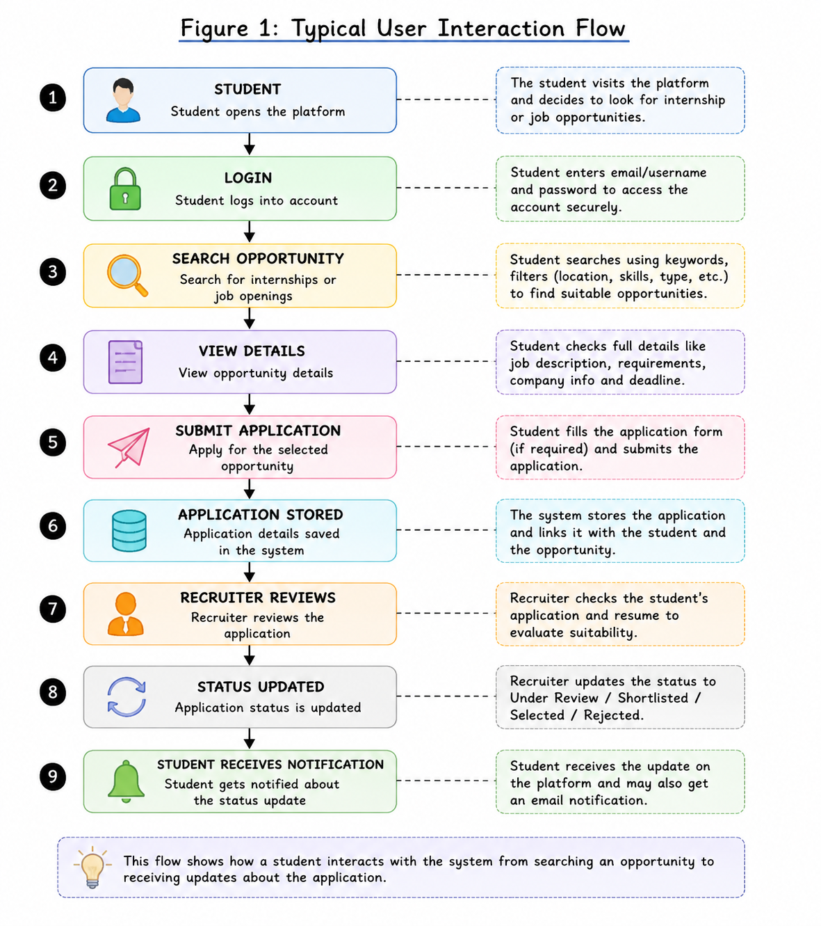
On the recruiter side, the company can log in and view the applications received for the posted opportunity. After reviewing a candidate, the recruiter can update the application status, for example from Applied to Under Review or Shortlisted. The updated status can then be shown to the student through the platform, and a notification can be generated if required.
This example shows how the different users and modules of the system work together during a real application process.

System Architecture

High-Level Architecture
The proposed system follows a simple three-layer architecture consisting of the Frontend, Backend/API, and Database. The purpose of separating these layers is to keep the user interface, application logic, and stored data organised into different parts. This should make the system easier to develop and maintain as more features are added.
The Frontend is the part of the system that users interact with. It will provide separate interfaces for students, recruiters, and administrators. For example, a student will be able to search for opportunities and manage applications, while a recruiter will have options for posting opportunities and viewing candidates.
The Backend/API layer acts as the main processing part of the system. It receives requests from the frontend and sends them to the appropriate module. The main modules planned for the backend are Authentication & User Management, Opportunity Management, Application Management, Notification Management, and Admin Management.
The Database layer will store the information generated by these modules. A relational database such as MySQL is suitable for this project because the system contains related information such as students, companies, opportunities, and applications.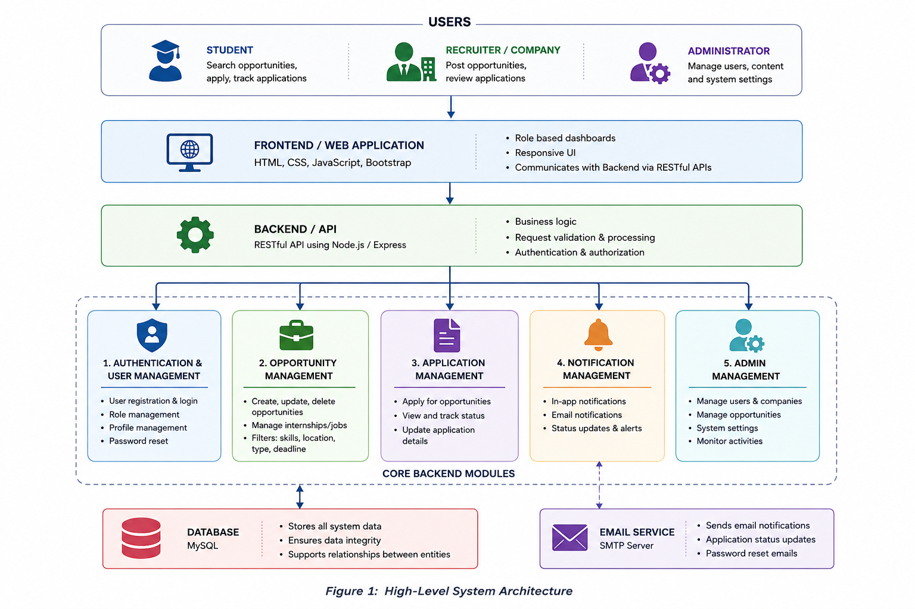
Component Interaction
The different components of the system communicate with each other based on the action performed by the user. The process generally starts from the frontend, where the user performs an action, and the request is sent to the Backend/API for processing. The backend then communicates with the required module and database before sending the result back to the frontend.
For example, when a student searches for a Java internship, the search request is sent from the frontend to the Opportunity Management module through the API. The module retrieves matching opportunities from the database and sends the results back to the student interface. Similarly, when a student submits an application, the Application Management module validates the request and stores the application details in the database.
When a recruiter reviews an application and changes its status, the updated information is stored in the database. The Notification Management module can then generate an in-app notification or send an email to the student. This shows how the frontend, backend modules, database, and external email service work together to complete a typical task.

Module Description
The system is divided into different modules so that each major function can be handled separately. This modular approach makes the project easier to understand and develop. Each module has its own responsibilities, but they communicate with other modules whenever required to complete a task.

1. Authentication & User Management
The Authentication and User Management module will handle user accounts and identify users when they access the system. Its main responsibilities include user registration, login, logout, profile management, password reset, and role-based access.
The system will have three main user roles: Student, Recruiter, and Administrator. After logging in, each user should only be able to access features related to their role. For example, a student can search and apply for opportunities, while a recruiter can post opportunities and review applications.
For security, user passwords should not be stored directly in the database. Instead, passwords should be stored in a hashed form. Authentication tokens or secure sessions can also be used to manage user login sessions. Keeping this functionality in a separate module will also make it easier to add future features such as email verification or two-factor authentication.

2. Opportunity Management
The Opportunity Management module will handle the creation and management of internship and job listings. Recruiters will be able to create new opportunities by adding information such as the job title, company name, description, required skills, location, type of opportunity, and application deadline.
Students will be able to search and filter opportunities based on their requirements. For example, a student looking for a Java internship in Kolkata can use relevant filters to find suitable opportunities instead of checking every listing manually.
This module should also allow recruiters or administrators to update or remove outdated opportunities. Keeping opportunity-related functions in one module will make the system easier to maintain. For example, if new filtering options such as salary range or work mode are added later, changes can mainly be made within this module without affecting unrelated parts of the system.

3. Application Management
The Application Management module will handle the process of students applying for internship and job opportunities. It will store application details and allow both students and recruiters to track the progress of an application.
For example, when a student applies for a Java internship, the system will connect the student's profile with the selected opportunity and store details such as the application date and current application status. The initial status can be set as Applied, and later updated by the recruiter to Under Review, Shortlisted, Selected, or Rejected.
Since applications are an important part of the system, the data should be handled carefully to avoid duplicate or incorrect records. The module should validate the application before storing it and maintain proper relationships between students, opportunities, and recruiters in the database. This will help ensure that application information remains organised and easy to retrieve.

4.Notification Management
The Notification Management module will be responsible for informing users about important activities and updates within the system. Notifications can be displayed inside the application and, where required, sent through an external email service.
For example, if a recruiter changes a student's application status from Under Review to Shortlisted, the system can generate a notification informing the student about the update. Similarly, notifications can be used to inform users about password reset requests or important application-related updates.
This module will need to integrate with other modules, especially the Application Management and Authentication modules. When an important event occurs, the relevant module can send information to the Notification Management module, which will then decide how the notification should be delivered. Keeping notifications as a separate module makes it easier to add new notification methods in the future.

5. Admin Management
The Admin Management module will provide administrative control over the overall platform. Administrators will be responsible for monitoring users, companies, and opportunity listings to help keep the system organised and reliable.
For example, if an administrator finds a fake or inappropriate internship listing, they can review and remove it from the platform. Administrators can also manage user accounts, company profiles, and reported content when required.
Access to this module should be restricted only to authorised administrators. This is important because administrative functions can make major changes to the system and its data. Role-based access control will therefore be used to ensure that normal students or recruiters cannot access admin functions. Separating administrative features into their own module also helps maintain a clear distinction between regular user activities and system management.

Data Flow and Integration

1. Overview of Data Flow
The data flow of the system explains how information moves between the users, frontend, backend modules, and database. Most actions start when a user interacts with the frontend. The request is then sent to the Backend/API layer, where the appropriate module processes it. If required, the backend retrieves information from or stores information in the database before sending the result back to the user interface.
For example, when a student searches for an internship, the search request is sent from the frontend to the Opportunity Management module. The module retrieves matching opportunities from the database and sends the results back to the frontend. Similarly, when a student applies for an opportunity, the Application Management module processes the request and stores the application details in the database.
Different modules can also communicate with each other when required. For example, when a recruiter updates the status of an application, the Application Management module stores the updated information. The Notification Management module can then use this update to inform the student about the change.

2. Application Data Flow Diagram

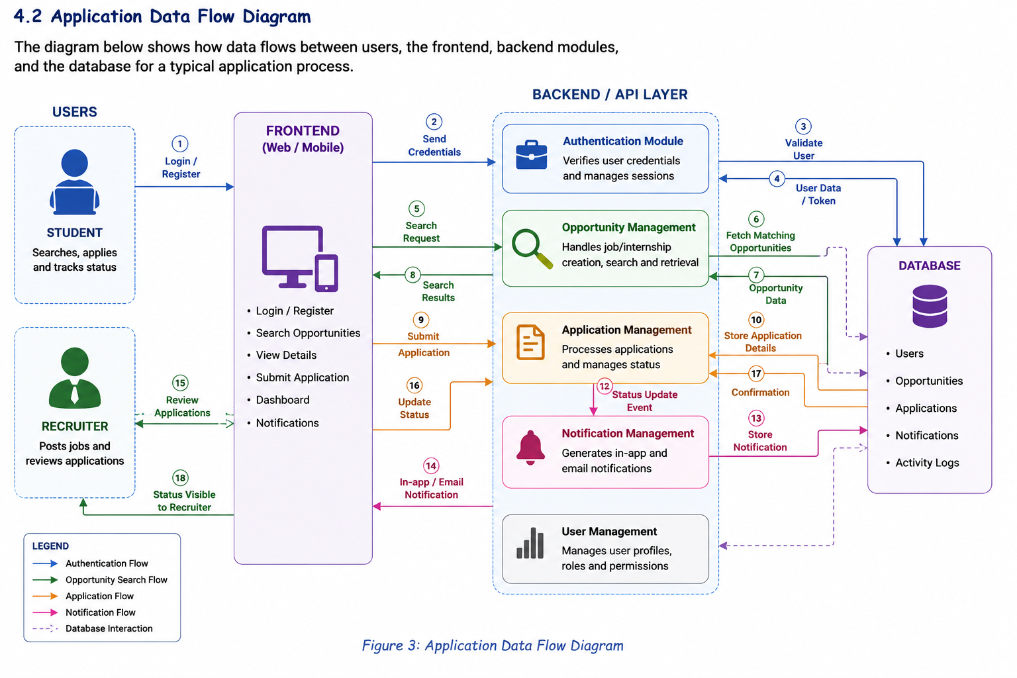

3. Example of Application Flow
A typical application process can be understood through the following steps:
Step 1: Search for an Opportunity
The student logs into the platform and searches for a suitable internship or job opportunity.
Step 2: View Opportunity Details
The student selects an opportunity and checks important information such as the company name, required skills, job description, and application deadline.
Step 3: Submit Application
If the opportunity is suitable, the student submits an application through the platform.
Step 4: Application is Stored
The Application Management module processes the request and stores the application details in the database.
Step 5: Recruiter Reviews the Application
The recruiter logs into the system and views the applications received for the posted opportunity.
Step 6: Application Status is Updated
After reviewing the application, the recruiter can update its status, for example from Applied to Under Review or Shortlisted.
Step 7: Student Receives Notification
The Notification Management module generates an update for the student. The student can see the new status on the platform and may also receive an email notification.
This example shows how different parts of the system work together during a normal application process.

4. External Integration
The main external integration considered for the system is an email service. The Notification Management module can connect with an email API or SMTP service to send important updates to users.
For example, if a recruiter changes a student's application status to Shortlisted, the system can send an email informing the student about the update. Email integration can also be useful for account verification, password reset requests, and important announcements.
Keeping the email service separate from the main system makes the architecture more flexible. If the email provider needs to be changed in the future, the notification functionality can be updated without making major changes to other modules. Additional integrations, such as resume storage or interview scheduling, can also be considered as future improvements.

System Design Considerations
While designing the Internship and Job Opportunity Management System, I considered a few important factors that could affect how the system performs and how easily it can be improved in the future.

1. Scalability
The system should be able to handle an increasing number of users, opportunities, and applications as the platform grows. For example, if the system is initially used by students from one college but later becomes available to multiple colleges, the number of users and application records could increase significantly.
The modular structure of the system can help manage this growth because different parts of the application can be improved separately when needed. The database can also be optimised using proper relationships and indexing to make searching for opportunities and retrieving application records more efficient. In the future, the system could also be deployed using cloud services if a larger number of users need to access it at the same time.

2. Security
Security is important because the system will store user information and application-related data. User passwords should not be stored directly in the database and should instead be stored in a hashed form. Secure authentication methods should also be used to manage user login sessions.
The system should also use role-based access control. This means that students, recruiters, and administrators will only be able to access the features relevant to their roles. For example, a student should not be able to modify another student's application, and only authorised administrators should have access to administrative functions. Input validation should also be used to reduce the possibility of invalid or unwanted data being submitted to the system.

3. Maintainability
The system is divided into separate modules such as Authentication, Opportunity Management, Application Management, Notification Management, and Admin Management. This makes the overall design easier to understand and maintain.
For example, if the notification system needs to be changed from email notifications to mobile push notifications in the future, changes can mainly be made to the Notification Management module without affecting the application or opportunity modules. Keeping different responsibilities separated can also make debugging and future development easier.

4. Future Improvements
Since this project is currently designed as a basic internship and job opportunity management platform, several additional features could be added in future versions. These may include resume upload and management, interview scheduling, company verification, advanced search filters, and personalised opportunity recommendations.
Another possible improvement could be adding analytics for recruiters and administrators. For example, recruiters could view the number of applications received for a particular opportunity, while administrators could monitor overall activity on the platform. These features are not part of the current core design but could be considered if the project is expanded further.

Conclusion

The proposed Internship and Job Opportunity Management System is designed to provide a structured platform where students can search and apply for opportunities, recruiters can post and manage listings, and administrators can monitor the overall system.

The architecture separates the system into different components such as the frontend, backend modules, and database. Important functions including authentication, opportunity management, application management, notifications, and administration are handled through separate modules. This makes the system easier to understand and allows individual features to be improved without affecting the entire application.

The data flow of the system also shows how these components communicate during a typical application process. Starting from a student searching for an opportunity to receiving an update about the application status, different modules work together to process and manage the required information.

While designing the system, factors such as scalability, security, and maintainability were also considered. The proposed design can serve as a foundation for future improvements such as resume management, interview scheduling, personalised recommendations, and additional notification features.

Overall, this architecture provides a clear high-level plan for developing the project. The diagrams and module descriptions helped me understand how the different parts of the system would interact before moving towards the actual implementation stage.

